APCO 2P99
2010/11

Project Peer to Peer

Problem Specification

Student: Navjot Minhas
Student Number: 4097762
Supervisor: Dr. D. Hughes
Program: Bachelor of Accounting
Date: Dec 19, 2010

Project Peer to Peer

What is the “Peer to Peer Project”?

The project is a peer to peer file sharing application which allows users to download unlicensed mangas and unlicensed fan subbed anime series. It will also give peers the ability to communicate amongst each other without relying too much on a central server to query files on the network and relay messages. In other words, unlike websites where people are able to download animes and mangas directly using a client-server model, the application will eliminate the use of a central server and will use peers for downloading and uploading instead. The reason for strictly fan-subbed material is that animes are usually spoken and portrayed in Japanese and in order for most people to understand them they must be translated into other languages.

What is this program’s competitive advantage?
What separates this from other peer to peer programs such as bit torrent and Limewire™ is that this program caters directly to the needs of users who watch anime or read mangas. It provides them summaries and updates of their favourite series, and it also allows them to search for new series based on genres and other attributes. Unlike Limewire, this program provides more variety for animes and mangas available on the network.

What is Peer to Peer?

What is peer to peer: it is a type of networking infrastructure which partitions tasks or work loads between other people on the network, they can also be referred to as peers. Peers are equally privileged, and share the same rights as other peers on the network. This means that there is no discrimination amongst the peers. Once these peers are connected to each other they form peer to peer network.

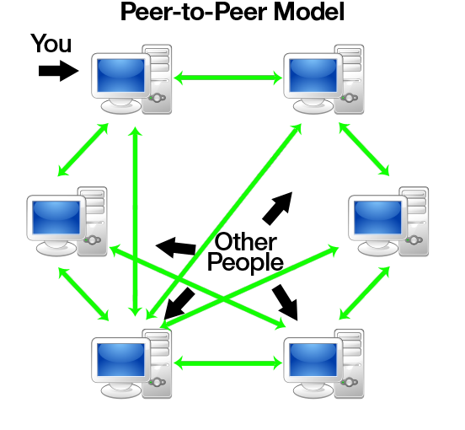

Figure 1: This figure depicts small a peer-to-peer system of nodes without central infrastructure. It gives a clear indication of how the network is still functional even if a signal node disconnects from this network.

What are anime and manga?

Manga: The word manga is a Japanese word which refers to Japanese comic books.
Anime: The word anime is also a Japanese word that refers to a style of animation originating in Japan, which are heavily influenced by mangas.

What is the target market?

This application is targeted toward a unique audience that share a common interest, watching anime or reading mangas. The age group of this niche usually ranges between the ages of eleven and twenty-two. Members of this audience usually tend to watch anime and read mangas for their own enjoyment. In addition, it is expected the audience will be sophisticated computer users, in regards that they will have the knowledge and skills to perform searches and download content off the network.

What are the constraints on this program?

The constraints of this program are the following:

- All resources made available to the network by a peer must be stored in one location on the computer. This provides security for users because it will not give others access to all the files on a computer. Thus restricting the access to any confidential information stored on a machine. Also this will provide some assistance on filtering the content on the network and keeping it strictly for anime and mangas.
- Since the project will be using JXTA, the framework requires membership credentials from all the peers on the network when they connect to the network for the first time. This allows peers to easily distinguish one another on the network and furthermore it makes it much easier for the application to bootstrap itself on the network.
- Even though new machines with latest operating system already have java runtime bundled with the installation, older operating systems such as Windows XP still require a java runtime to be installed for the program to execute on a computer.
- The program must be loaded on a peer’s computer when they want to connect on to the network.
- In order for users to know what episodes are subbed in English, and any other languages, it is required that peers organize their content into the folders respectively based on language.

What are the different parts of the program?

Home Tab: This tab provides the user with all sorts of information. Its main purpose is to allow the user to discover new anime or manga series. Its secondary purpose is to provide updates on series that they are currently watch or streaming.

- The My Personal selector is responsible for showing the user updates on anime and managa series that the user is currently watching or reading. In other words, this feature will act as a news feed for users and provide them information on their favourite series.
- The Series selector is responsible for showing users most of the anime and manga series available to them. It will provide them with a list of anime and manga series which when clicked will bring up a list of all the episodes and chapters in the series.

Search Tab: In this tab users are presented with a search box in which they use to find resources from other peers on the network. Once the user enters a search string and hits the search button, the program will search the network and return the results as shown below. In addition, the search tab will allow users to automatically sort and filter out the list of search results based on a certain criterion.

Download Tab: This tab shows the download progression of files that are being downloaded from other peers. The amount downloaded will be presented with a progress bar along with other information about the file.

Library Tab: This tab will show all the files in the user’s shared folder.

Forums Tab: This tab will allow users to access the development forum directly in which they can do the following:
- Find out any information on the application regarding updates.
- Report any bugs or glitches that they have encountered.
- Ask for assistance about the application and its functionality.
- Meet and collaborate with other users using the application.

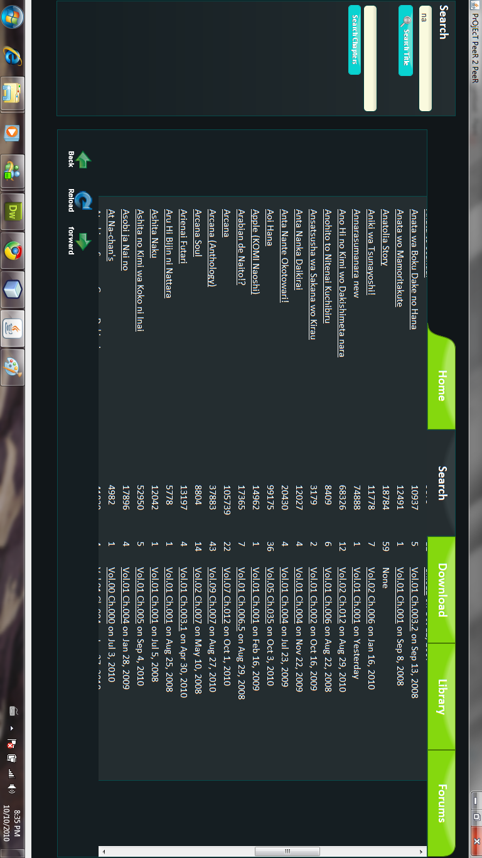
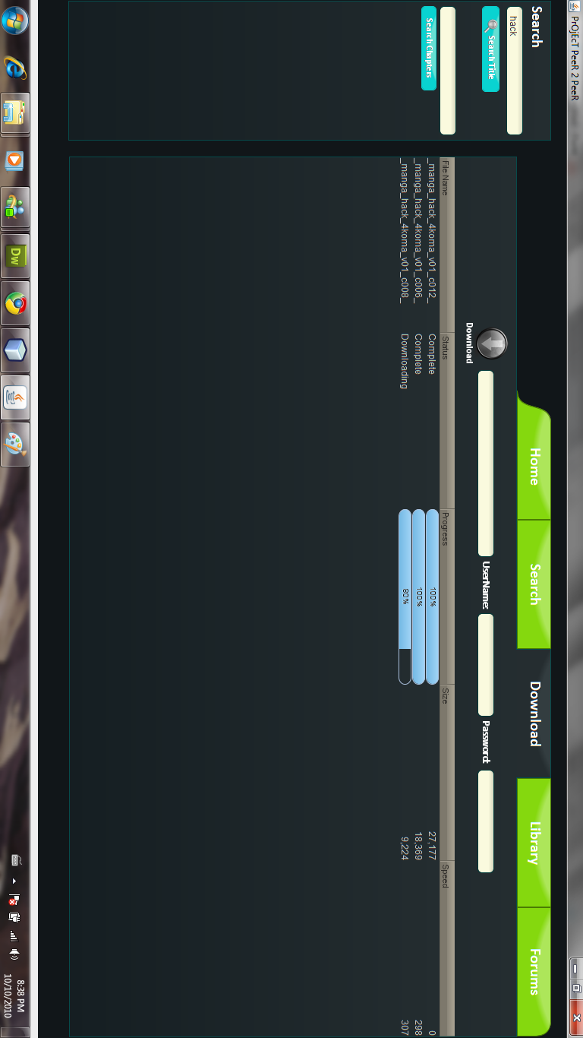

Reference: Joseph D. Lien, “A guide to peer-to-peer filesharing (part1)”, Friday, 3. September 2010, http://my.opera.com/portalnews/blog/2010/09/03/a-guide-to-peer-to-peer-filesharing-part-1(accessed October 27, 2010)

